The Saint Nicholas Community introduces a new daily after-school program of cultural enlightment of our Greek heritage for school ages  K through 8th  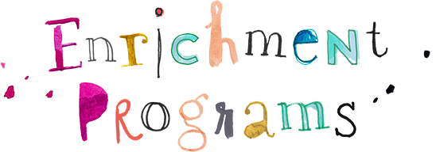  This program offers:  - Byzantine Choir  - Traditional & Modern Choir  - Drama/Theatre  - Dance  - Mythology  - Physical Education  - Arts & Crafts  - Christian Orthodox Life Sessions  - Cooking  - Homework Time | St Nicholas Greek Orthodox Shrine Church  196-10 Northern Blvd, Flushing, NY 11358  Flushing, NY – 11358 |  | Stephen & Areti Cherpelis  Hellenic Orthodox Life Academy  of Saint Nicholas Church  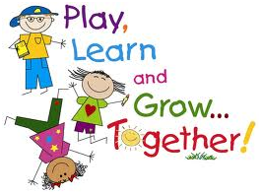  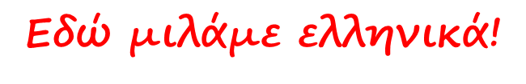

ABOUT THE HELLENIC ORTHODOX LIFE ACADEMY  The Hellenic Orthodox Life Academy – HOLA is a new after-school program that meets daily and gives students the opportunity to engage in fun activities while practice the Greek language. It offers a full range of cultural, educational, arts, recreational, and fitness programs which allow children to grow physically, intellectually and socially while getting to know closely their Greek heritage and speak the Greek language. The Hellenic Orthodox Life Academy is committed to providing a safe after-school program with the safest nurturing environment.  YOUR CHILD’S DAY  HOLA starts daily at 3:45pm and runs through 6:00pm. Children meet in the program’s central meeting area where attendance is taken and snack is given out. Children gather at the same area once program ends. There are a number of enrichment classes offered for each semester. The programs described in this brochure indicate the appropriate grade level for each class. Many courses have a limited number of spaces. All applications are entered in the order that they are received by the church office.  PROGRAM CLOSINGS  Whenever the William Spyropoulos day school is closed, the after-school program is closed. If the school cancels other after-school activities, this program is also closed. The HOLA program may also be closed due to inclement weather. For this reason, make sure that all emergency numbers are kept updated. You may call the church office for updates. | REGISTRATION FORMS  A Registration Form is included with this brochure. To register your child, complete the form and mail it or bring it with full payment to:  St Nicholas Greek Orthodox Shrine Church  196-10 Northern Blvd, Flushing, NY 11358  FEES AND PAYMENT POLICY  The HOLA program runs in two semesters, the fall and the spring. Registration occurs two times per year. Payment is due at the time of registration, and there are no refunds or make-ups for absences or missed classes. HOLA offers a sibling discount of 10% for every child after the first. All forms must be returned to the church office before your child begins attending the program.  REFUND POLICY  Prior to the session beginning–100% Between the 1st and 4th class–50% After the 4th class–No refund  CONTACT US  St Nicholas Greek Orthodox Shrine Church  196-10 Northern Blvd, Flushing, NY 11358  Tel:(718) 357-4200 | 