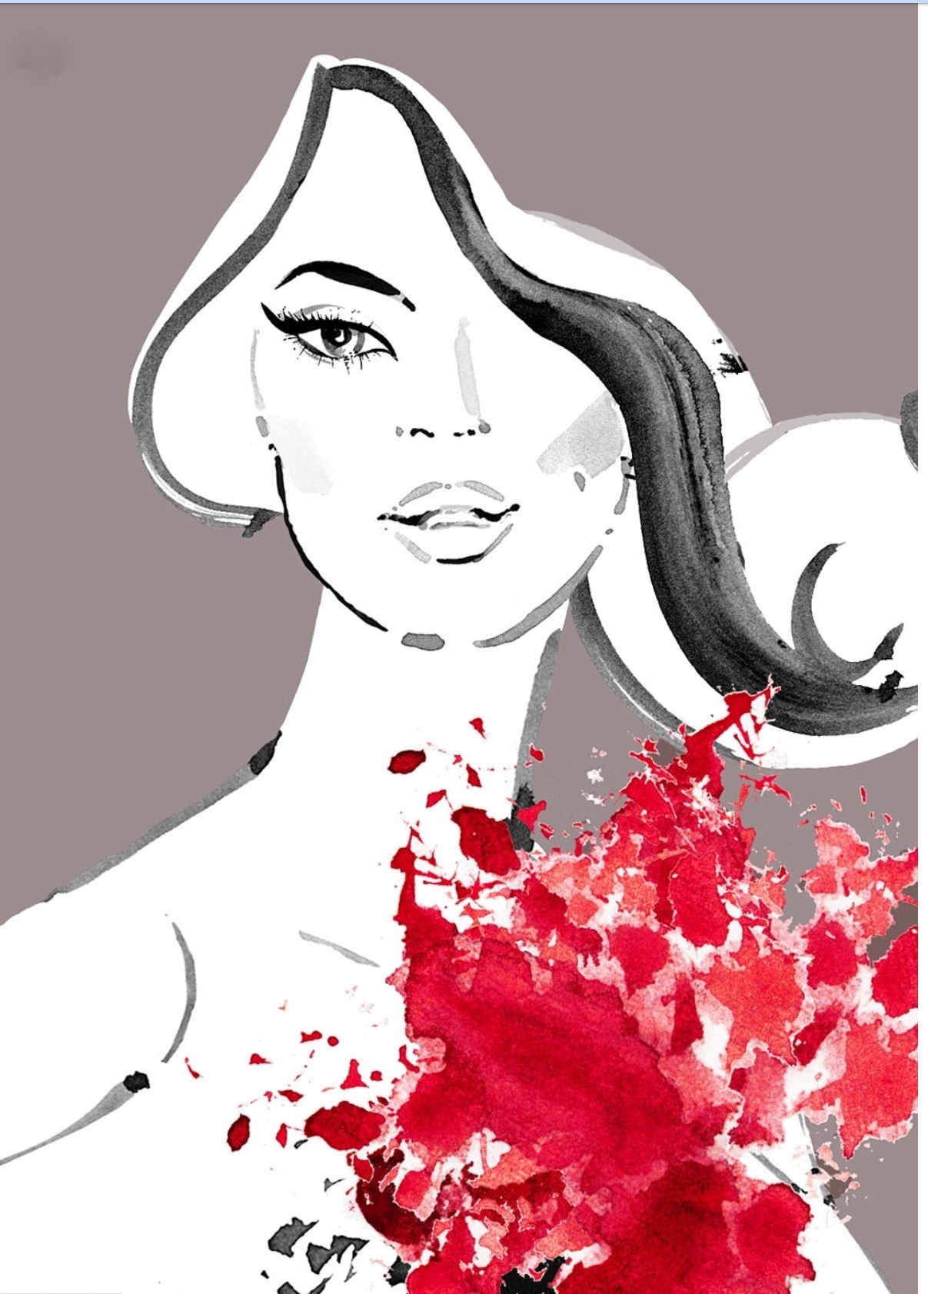

**SAVE THE DATE!**

**Tres Chic…It’s all about you!**

**“FASHION SHOW”**

***Thursday, April 19, 2018***

***7:00PM***

***Sand Castle***

505 Franklin Ave, Franklin Square, NY

***Presenting Women and Men’s Fashions***

***By Lord and Taylor***

***Featuring:***

*Music, Dinner and Dancing, Couture Raffles*

*And much more!!*

***\*Invitation to follow\****

The Ladies Philoptochos Society

*St. Nicholas Greek Orthodox Shrine Church, Flushing, NY*

**\*\*\*\*\***

The Proceeds of this event will benefit many of our Charitable Organizations